LOCAL ARTIST KELLY SLATER AND THE SAUGUS PUBLIC LIBRARY INVITE YOU TO JOIN THEM FOR
“EXPRESS YOURSELF! FUN AND EASY ART EXPERIMENTS”

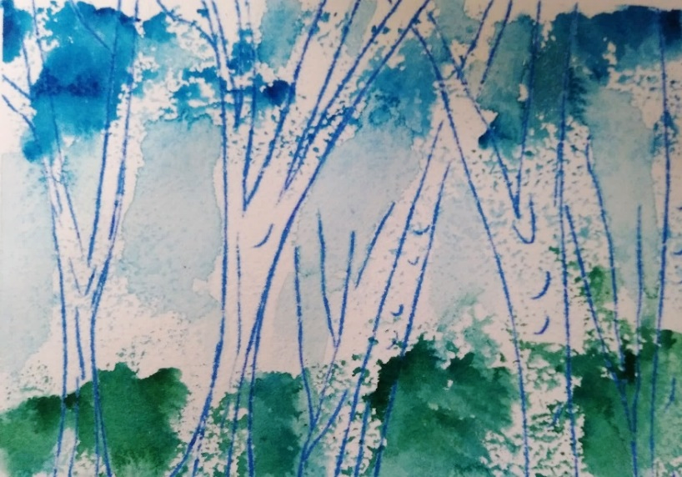
Kelly Slater teams up with the Saugus Public Library this winter and spring to present four free online workshops, “Express Yourself! Fun and Easy Art Experiments.” Ranging in subject from kitchen table printmaking to artist’s accordion books, the workshops share a common emphasis on fun and experimentation. No previous art experience is required and all art supplies will be provided free at the Saugus Public Library in “Take and Make” bags.
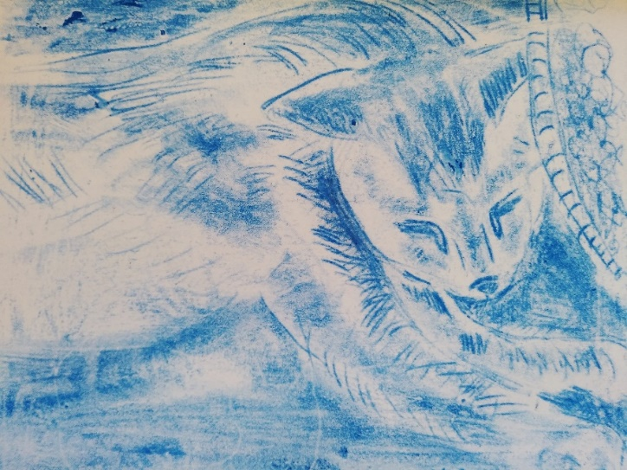
The series will kick off on Thursday February 25th with “Kitchen Table Printmaking.” Participants will explore the many possibilities of making “trace” or “transfer” prints using common arts and crafts supplies, as well as office supplies. In the second workshop, held Thursday March 11th, we will explore several different ways of making watercolor prints. The third session, scheduled for April 15th, will focus on drawing experiments and will invite participants to overcome any and all fears of drawing by letting go of control. Finally, the series will conclude on Thursday April 29th with a foray into making accordion-style artists books. All four sessions will last 90 minutes—running from 6:30 - 8:00 pm on a Thursday.
Workshops are open to ages teens through adults. Students may sign up for anywhere from one to all four sessions. Advance registration is required through the Saugus Public Library. Zoom information, as well as information about how and when to pick up “Take and Make” art supply bags, will be sent to all registered students. Space is limited--so be sure save your spot by registering by February 22nd at the latest for the first workshop.
At the end of the four sessions, interested students can submit class work for a virtual art exhibit, hosted through the Saugus Public Library website.
Kelly Slater (www.kellyslaterart.com) is a self-taught artist who specializes in abstracts of landscapes and trees. For the past several years, she has focused on the landscapes of New England. Her philosophy is that art making is not just for experts. Instead, art can and should be fun and accessible. All people can improve both their artistic skills and their quality of life simply by making art into a playful and experimental form of recreation.
To reserve your space at the free workshop, send an email to sau@noblenet.org with “SPL workshops” in the subject line. If you have questions about the content of the workshops, please contact Ms. Slater at kellyslaterart@hotmail.com with “SPL workshops” in the subject line

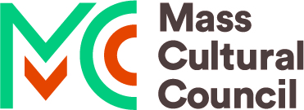
This program is supported in part by a grant from the Saugus Cultural Council, a local agency which is supported by the Mass Cultural Council, a state agency. Zoom support provided by the Saugus Public Library and select art supplies provided by your local Artist & Craftsman Supply, located at 751 Broadway (Rte. 1 S) in Saugus.

